ORISSA ELECTRICITY REGULATORY COMMISSION
BIDYUT NIYAMAK BHAWAN
UNIT-VIII, BHUBANESWAR - 751 012
************

Present : Shri K.C. Badu, Member
Shri B.K. Misra, Member

Case No.1/2010

Director (Engg.), OERC …. Petitioner
Vrs.
GRIDCO & Others …. Respondents

In the matter of: Order (Protocol) on Power Regulation in the State under Section 23 of the Electricity Act, 2003.

Date of Hearing : 08.01.2010

Date of Order : 14.01.2010

ORDER

Background

The Power supply situation in Orissa is now passing through a critical stage. The hydro reservoirs in the state which are the backbone of the power supply system in Orissa are in depleted situation. The thermal power stations are not able to deliver their full potential due to various factors like non-availability of coal etc. Some of the IPPs who were supposed to start operation by this time have yet to come up due to various inherent problems like land acquisition etc. The CGPs in the State are also unable to deliver their surplus power to the State as per our requirement, mostly due to difficulties faced in supply of coal in time. The Retail Supply tariff in Orissa is low compared to those in other States. The power required to meet the deficit (in case available) from outside the state shall be at an exorbitant rate which the general consumers of the state may not be able to afford when they were enjoying low tariff for several years. In this scenario, it is inevitable that there is need of demand management in the use of energy by all categories of consumers including industrial consumers of the State.

2. Regulation of Power is normally required due to mis-match of supply and demand. Whenever the demand exceeds supply, frequency drops. Excessive drop of frequency can cause imbalance in the system. Additionally, in the present integrated NEW grid operation in the country (i.e. except southern grid), any drawal exceeding the schedule from the inter-state grid sources at low frequency may endanger security in the national grid, and has resulted in imposition of penalties by the CERC on many state utilities in the past.

3. Under such circumstances the Commission is mandated to take action under Section 23 of the Electricity Act’03, which states “If the appropriate Commission is of the opinion that it is necessary to expedient so as to do for maintaining the efficient supply, securing the equitable distribution of electricity and promoting competition, it may, by order, provide for regulating supply, distribution, consumption or use thereof”.

Procedural History

4. Before issuing any order under Section 23 of the Electricity Act, 2003 on Power Regulation, for the better transparency, the Commission decided to make a wider consultation on the matter with all stake holders. The staff of the Commission prepared a consultation paper on the subject and it was published on the Commission web site. Public notice was also published in the Daily Newspapers i.e. New Indian Express on 06.10.2009, in Sambad, Samaj, Times of India on 07.10.2009 and in Pragatibadi on 08.10.2009. In order to invite views on the matter by the stake holders, letters were also issued to Department of Energy, Water Resources Department, Govt. of Orissa, CMD GRIDCO, OPTCL, Sr. G M (PS) SLDC, CEO, CESU, NESCO, SOUTHCO, WESCO, MD, OHPC, OPGC to furnish considered views to the Commission. Commission also issued a letter to other interested persons to submit their views on the matter.

5. In response to the said public notice/letters the following persons/licensees have submitted their views on the matters in writing.

1. GRIDCO, 2.OPTCL, 3. SLDC, 4.CESU, 5.WESCO, 6.NESCO, 7.SOUTHCO, 8.Dept. of Energy, GoO, 9.Sri K.P.Rath, 10. Sri M.V.Rao(FACOR), 11. Sri R.Pandey(OCL), 12. Sri S.K.Patel (L&T), 13. Balasore Alloys Ltd., 14.UCCI, 15.Sri Santosh Das,C.P.I.(M) 15.Sri Bibhu Charan Swain, (Power Tech Consultants), 16. Sambit Mohanty,(OIEA), 17.Sri B.K.Mohapatra (Member SAC), 18. Sri Ramesh Satpathy,(NIIL) 19. Sri N.K.Panda, (CAA), 20.Sri K.K.Lenka, 21.Sri A.R.Mohanty, Ex-Member, OERC, 22.Sri D.K.Roy, Ex-Chairman, OERC, 23.Asst.Secy, (OCA), 24.Rourekal Chamber of Commerce & Industry, 25.Sri S.K.Nanda (CII), 26.Sri R.P.Mohapatra, 27. Sri C. P. Bhartia, (J. Polymer (Pvt.)Ltd.,28.Sri Sanjib Das(CCPPO),29. G.N.Agarwal, (SDCF),30. Sri D.D.Atal, (OCL), 31.Sri Debasis Mohanty (NOCC&I),32.Sri Himansu S.M.(DLC), 33. Chief Manager(ACC Ltd.),34.Sri B.C.Jena, Ex-Member, OERC, 35.Sri Sanjay Pratap (AMLtd.), 36.Sri S.S.Kalia, (JCL) & 37. Sri Vivek Patnaik,(Ex-Secy, Energy).

GRIDCO and four Distribution Licensees i.e. WESCO, NESCO, SOUTHCO and CESU have submitted detailed Load Management for different scenarios on the issue of standard Load Shedding Protocol proposed to be implemented in the State. GRIDCO in its written submission has also prayed for (i) limiting the demand as per power available keeping in view its financial constraints or (ii) to bridge the gap in its annual revenue requirement through tariff hike and or Govt. subsidy/grants. The summary of the submission made by the other persons are in Annexure-1 to this order.

- Commission conducted a consultative hearing on 08.01.2010 after issuing notice to the GRIDCO, OPTCL, SLDC, all Distribution Licensees, Department of Energy, Department of Water Resources, OHPC, OPGC & other persons who have submitted their considered views on the matter by writing. In response to the said notice the persons present in the hearing are listed in the Annexure -II to this order.

- Director (Engineering) as a designated petitioner gave a power point presentation on the requirement of Regulation of Power in the State of Odisha. He vividly explained the power deficit situation in the State and Commission’s Statutory Power to issue direction to the licensees by way of order(s) under Section 23 of the Electricity Act of 2003 for regulation of Power in the State. In present situation such direction by the Commission is imminent for maintaining efficient supply and securing equitable distribution of power, he pleaded.

- During hearing the participants raised the following important issues:

- The Commission should effectively monitor the activities of the licensees with regard to implementation of its order on Power Regulation.
- Demand Side Management measures should be implemented effectively by sensitizing the consumers in order to the reduce gap between the demand and supply.
- The industrial consumers are ready to pay higher tariff for uninterrupted power supply and there should not be any load restriction on them. Due to power restriction, not only the revenue of the licensee will be affected but also the revenue of the Government will suffer due to lack of industrial production.
- During power regulation, there may be law and order problem which is to tackled by the Government effectively.
- Distribution Licensees should publish detail about the schedule power cuts in the print and electronic media so that the consumer will able to get prior intimation.
- Initiative may be taken by the Government/ Licensees to educate and sensitize the consumers about the conservation of energy. Government may issue circulars about the conservation of energy in the Govt. office buildings.
- Energy Audit may be made in the industries/ large official buildings for efficient use & conservation of electricity.
- DISTCOs should restrict their drawal within the schedule as decided by the SLDC.
- There should not be any hand tripping of any feeder by OPTCL without prior intimation to the DISTCOs.
- There should be proper coordination between Gridco, OPTCL, SLDC and DISTCOs about the scheduled load shedding.

- The summary of the views presented by each of the persons during the hearing are summarized below:
    - Shri M.V.Rao
- Industries are most sufferers due to restriction of power supply although 50% of power is being consumed by them.
- Licensees are imposing restrictions even without any formal order by any authority.
- The order dated.20.06.2009 on load restriction to the Industries of the Commission has not been adhered to by the Licensees/OPTCL. The restriction imposed on the industries are much higher than that of Commission’s order.

    - Shri R. Pandey
- OCL is ready to pay extra tariff if uninterrupted power supply is extended to their industry. As it is a continuous process industry it can’t run with 25-30% reduction as involvement of all the equipments are required for production of ultimate product.

    - Shri S.K.Patel
    - There should be sharp distinction between honest and dishonest consumers. Honest consumers should be given preferential treatement.
    - There should not be any tripping and higher tariff is acceptable for uninterrupted power supply.
    - Rebate for the use of electricity during off-peak hours may be enhanced.

    - Shri Santosh Das
- Agriculture and study hours of the students should not be affected due to Regulation of Power.
- Govt. should initiate action for increase in generation capacity and allocation of more central sector power to meet the deficit situation.
    - Shri Sushanta Ku. Jena
  - DSM measures to be adopted effectively. The licensees should provide load limiters in the feeders, prepaid meters for the consumers, capacitor banks for voltage improvement and moreover to take steps for public awareness for efficient use of electricity.
    - Citizen Apex Association
  - Effective steps should be taken to reduce T&D loss so that the proposed power cut can be avoided.
    - Shri S.K. Nanda
  - Regulation of power should be up to June-2010 as the hydro situation is expected to improve by that time.
  - Restriction in energy drawal in case of industries shall hamper their production.
  - Energy efficient bulbs & equipments etc. should be provided by the licensees/Government.
    - Shri R.P. Mohapatra
  - Gridco should furnish the month wise energy requirement by the DISTCOs and ultimately the requirement of the State.
  - Costly power purchased by Gridco without the Commission’s approval should not be loaded to the consumers in the tariff.
  - Industries can be regulated round the clock on consumption basis to ensure equitable distribution.
  - Demand charges should be charged on restricted demand.
    - Shri G.N. Agarwalla
  - There should be proper coordination between Water Resource and Energy Deptt of GoO. Govt. should publicize the reason of load restriction.
  - Unnecessary use of electricity in the Govt. buildings should be stopped.
Govt. should take steps for removal of silt in the hydro reservoirs.
- Agriculture and study hours of the students should not be affected due to Regulation of Power.
    - OCL, Rajgangpur
  - Agreed to pay more for uninterrupted power supply. It was stated that OCL produces clinkers and also cement. Clinkers so produced by OCL is used by its sister unit at Manguli, Cuttack district.
    - Shri Himanshu Mohapatra
  - Rural, Urban discrimination of power cut should not be there.
  - As a long term solution to the problem, Govt. should take effective steps for completion of power projects in the State.
    - Shri Bibhu Charan Swain
  - Effective steps for Energy Conservation & DSM should be taken up immediately.
  - As first step, Energy Audit should be carried out for large industries & Govt. buildings
  - There should not be any discrimination of power cut between Rural & Urban consumers.
    - Shri Vivek Pattnaik
  - Tariff rise is essential for growth & sustainable development of the Sector. CPPs in the pipe line should be approached and bottled up power should be harnessed.
  - Police action should be provided by Govt. for effective control of theft of energy.
  - OERC should discuss the issue with the Govt. as the power situation for future is not encouraging and deficit situation is likely to continue.
    - CESU
  - As CESU is catering the demand of important areas/establishments, hence imposition of restriction should be least. Also most of the functions of national importance are being held in this area. It was agreed that the DSM and Energy Conservation measures are required to manage deficit. Under frequency relays to be installed in the loss making feeders to limit excessive drawl at low frequency.
    - WESCO
  - As restriction is unavoidable, we have to manage with the power available so cooperation from all the stake holders is required to overcome the situation.
  - OPTCL should not hand trip the feeders when WESCO is drawing power within its schedule.
    - NESCO
  - NESCO is facing difficulties and practically impossible to adhere to the schedule when it is much below the demand. Communication from the Govt. side is required to avoid public discontentment when there is power cut.
  - Escrow relaxation is required for Operation & Maintenance expenditure as revenue expected from the industries shall be less due to load restriction.
    - SOUTHCO
  - Hand tripping by OPTCL without prior intimation should be avoided. Consumers should be well intimated about the power crisis either by the Govt. or OERC to avoid public discontentment.
  - DSM measures like Bachat Lamp Yojana has just started, need to be speeded up.

    - OHPC
  - It is expected that there will be generation of around 300 MW from hydro sources after 10.01.10. This may reduce the deficit, other factors remaining the same.
    - OPTCL
  - OPTCL is tripping the feeders on the instruction of SLDC only, for the safety and security of the system. DISTCOs are to provide breakers in their 33 kV feeders. OPTCL is now procuring numerical relays with provision of under frequency settings for installation in the outgoing feeders of its 132/33 KV S/S with graded frequency.

    - SLDC

  - DISTCOs are regularly violating the schedule and drawing more for which ERLDC is issuing nos. of strictures. SLDC is taking actions required for the safety of the system and also trying to avoid drawal of costly power.

    - GRIDCO

  - One hour over drawal costs additional requirement of 4 crores. Hence, regulation of power should be in position and all the DISTCOs should adhere to it. It is unmanageable now to run the organization with a monthly default of Rs.200 crores without Govt. support. UFRs be installed in the outgoing feeders of the OPTCL S/S at frequency between 49.5 HZ and 49.2 HZ for curtailment overdrawl from eastern grid at low frequency.

    - DoE,GoO

  - The Commission can evaluate the situation and take appropriate action.

- Statutory Provisions

Section 23 of the Electricity Act’03 provides that:

If the appropriate Commission is of the opinion that it is necessary to expedient so as to do for maintaining the efficient supply, securing the equitable distribution of electricity and promoting competition, it may, by order, provide for regulating supply, distribution, consumption or use thereof.

- Role of the State Government in Generation, Transmission and Supply

(a) Section 11 (1)of the Electricity Act’03 provides that:

The appropriate Government may specify that a generating company shall, in extraordinary circumstances operate and maintain any generating station in accordance with the directions of that Government.

Explanation : For the purposes of this section, the expression “extraordinary circumstances“ means circumstances arising out of threat to security of the State, public order or a natural calamity or such other circumstances arising in the public interest.

(b) Section 37 of the Electricity Act’03 provides that:

The appropriate Government may issue directions to the Regional Load Despatch Centres or Sate Load Despatch Centres, as the case may be, to take such measures as may be necessary for maintaining smooth and stable transmission and supply of electricity to any region or State.

The field of operation of Section 37, as its position in the scheme of the enactment suggests, as transmission, and purpose of any directions issued under that provision has to be maintenance of smooth and stable transmission and supply of electricity “to” the state and not regulation of electricity within the state. The directions should, for example, relate to maintenance and improvement of state grid, observance of grid standards etc. Hence, the primary responsibility of directing imposition of power regulation lies with the Commission.

- Role of SLDC

(a) Section 32(2)(e) of the Electricity Act’03 provides that:

SLDC is responsible for carrying out real time operation for grid control and despatch of electricity within the State through secure and economic operation of the State grid in accordance with the Grid Standards and State Grid Code.

(b) Provision in Orissa Grid Code Regulations, 2006

SLDC shall endeavour to
- Restrict actual drawl within schedule from Regional Grid
- Maximise Generation at all SGS/CPP at low frequency
Requisite load shedding by SLDC’s instruction to be carried out

- Aim of the Standard Load Shedding Protocol

In view of the statutory provision contained in the Section 23 of the Act, one of the important parameters to be contained in the directives issued by the Commission to the Licensees is for securing equitable distribution of electricity. Therefore, the aim of the Commission is that, once the quantum of overall load shedding requirement in the State is ascertained by the SLDC, based on demand supply situation as per existing practice, Standard Load Shedding Protocol shall provide guidance for equitable sharing of quantum of shedding among the distribution licensees and the consumer areas without any discrimination.

The method to ascertain the gap between demand and supply & consequent measures to reduce the overall load shedding amount requirement for the state is, however, beyond the scope of the present exercise.

- Power Scenario in the State

The power situation in Orissa in the post reform period was comfortable. OHPC, OPGC, TTPS and Central Sector share made Orissa comfortable in power availability and demand was less than availability. Orissa was in overall energy surplus situation, and there was generally no deficit even during the summer months in the State. However, the position has changed drastically over the past couple of years, due to increase in demand, and no addition of any new generating units in the state. In summer months, the hydro reservoirs generally become dry and due to monsoon failure, the hydro power availability goes down. Added to it, due to the problem in coal supply and equipment trouble, thermal plants can not run to the full capacity. Hence, the State has to face shortages which results in licensees resorting to load shedding as sufficient power is not available.
- Overall Demand Supply Scenario (Past Trend)

(a) The picture of overall demand and supply position of annual energy requirement of the State can be viewed at the following table and the graph, which shows the change in this position from 2002-03 to 2008-09. (shown on quarterly basis)
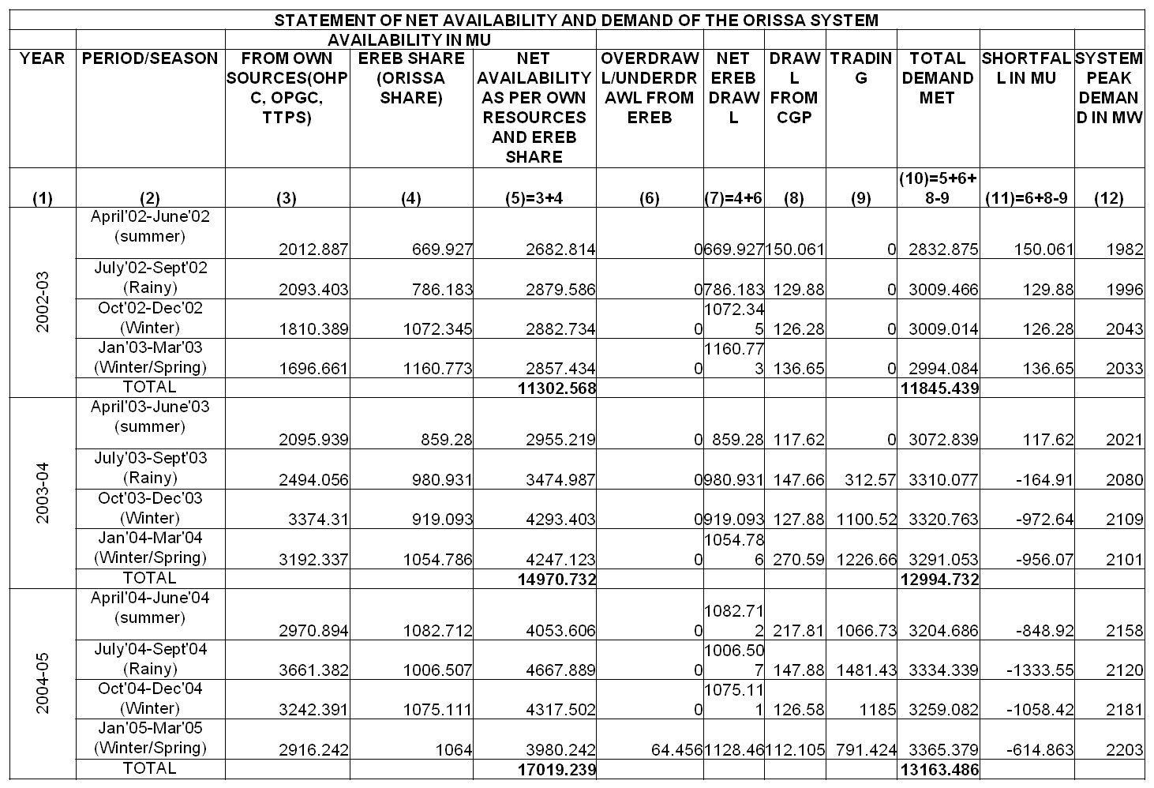
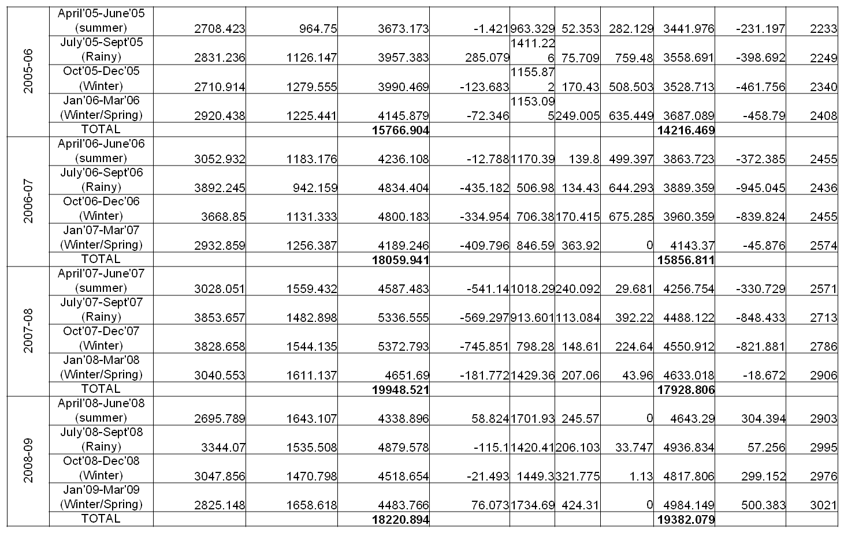
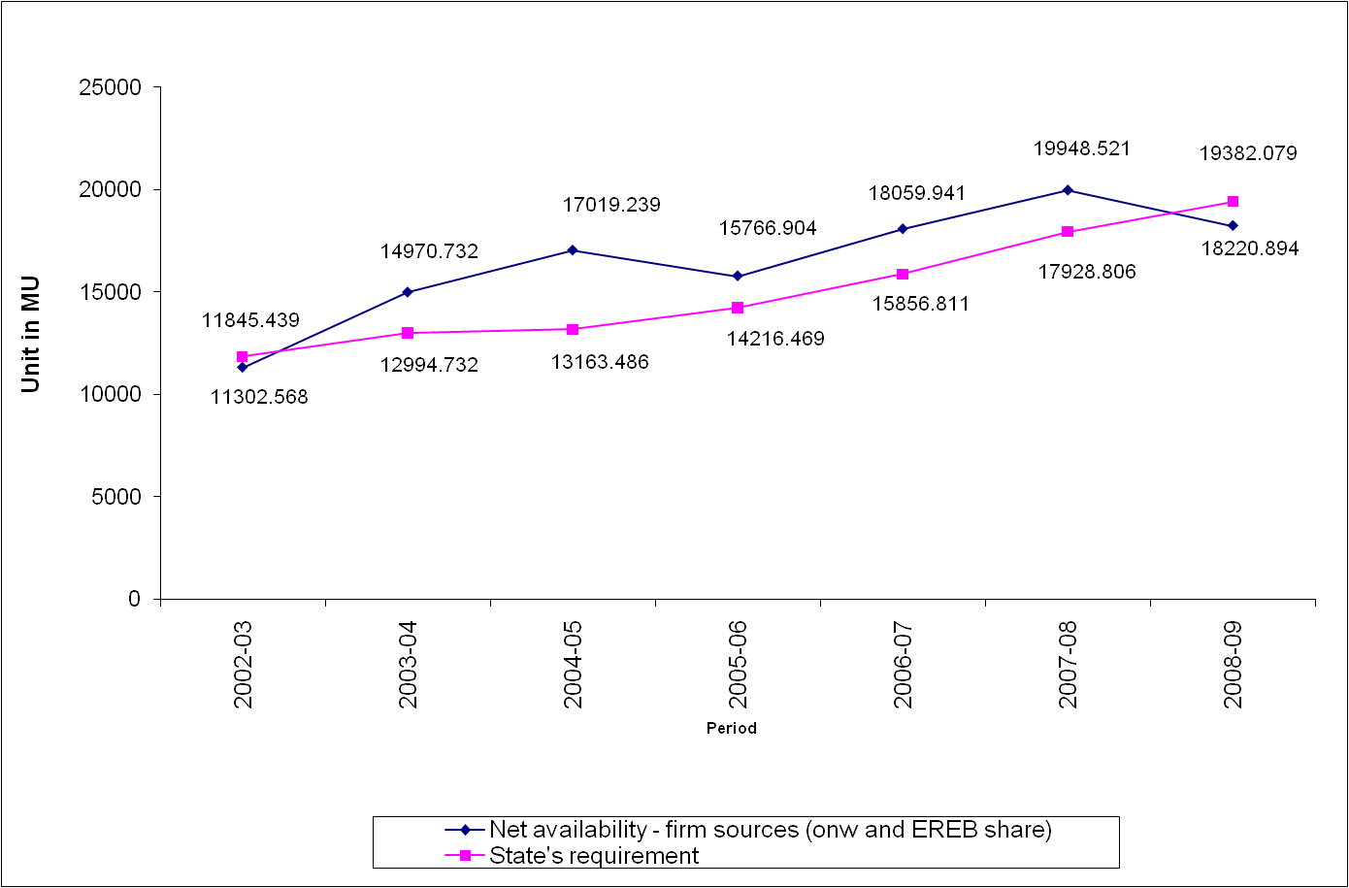
(b) Inference from the demand supply position:
The gap between availability and State’s energy requirement has narrowed down from 2003-04 to 2007-08 and in the middle of 2007-08, the availability nearly matched the State’s demand. In the end of 2008-09, the availability has fallen below the State’s requirement. The situation may worsen further because of returning the power to the States who had helped Orissa to tide over the power crisis during last summer. The only option left with the GRIDCO/SLDC are to restrict drawl of distribution licensees or buy power through trading route along with over drawl of power from the eastern grid through UI mechanism, which is not only at costlier rates but is also limited in quantity. Distribution companies in turn have no other recourse but to go for load shedding.
- (a) Overall Demand Supply Scenario (Recent Trend)

Note: The unrestricted peak requirement of the state is about 3100 MW.
(b) GRIDCO procures power from the following sources to meet the demand of the
state:
State thermal : 880 MW
State Hydel : 2,085 MW
Central allocation : 1,035 MW *
Total : 4,000 MW

*This value has been taken as per the 100% availability of the generating units. The generating capacity vary from time to time depending upon the availability of units.

The present actual demand of the state is around 3100 MW. However, due to restricted availability as shown in the above table, the state is able to meet around 2700 MW restricted demand (Column-7).

Present availability of power –

Thermal : 600 MW against the capacity of 880 MW.
Hydro – 60 MW against the capacity of 2085 MW.
CGPs – 500 MW
Central Sector – 1400 MW drawal against the existing schedule of 700 MW.

Hence, there is a gap of around 700 MW between availability and the demand at present and to meet the above situation, there is need of power regulation in the area of the DISTCOs in proportion to their quantum of energy drawl approved during ARR & Tariff of 2009-10.

- Load Regulation Procedure, generally followed in the past :

In the past, whenever there was shortage of power the load shedding was done as per instructions of SLDC in the following manner:

If the demand was 1000 MW and there was shortage of 100 MW, it meant there was availability of 900 MW. If the connected loads in the DISTCOs were in the ratio 3:2:4:1, then the power was made available to respective DISTCOs as 3/10X900=270 MW, 2/10X900=180 MW, 4/10X900=360 MW and 1/10X900=90 MW respectively.

DISTCOs were supposed to restrict their drawl according to its entitlement.

- Initiatives by the Commission

- During a meeting held in the Commission on 23.09.09, GRIDCO/OPTCL have submitted a contingent plan of load management programme.
- The Commission thereafter decided to go for wide public consultation in the matter of power regulation in the state and accordingly comments/suggestions have been invited from the interested parties including consumer organizations, distribution companies and general public through public notice dt.5.10.2009 for finalization of a standard Load Shedding Protocol in the state under the power deficit situation.
- GRIDCO and the DISTCOs have proposed power regulation such that the following general principles are adhered to:
Emergency supply like hospital, railways, water supply etc. – no restriction.

Bhubaneswar – one hour during morning peak and one hour during evening peak.
Dist HQ – one hour during morning peak and one hour during evening peak.
Urban – two hour during morning peak and one hour during evening peak.
Rural – two hour during morning peak and two hour during evening peak.
Industries – 25% restriction.

- Issues
The Stake holders have raised certain issues/views in their written submission in response to the consultative paper, which have been summarized below:
1. Govt. of Orissa has stated that the Commission may evaluate the situation and take appropriate action in the matter.
2. Other stakeholders have stated as below:
- Theft of energy should be curbed
- There should be addition of generation capacity.
- There should be action to reduce technical as well as AT&C loss.
- Hydro plants should not be stopped at any cost.
- Central Govt. should be impressed upon to allocate power from 15% unallocated quota and Orissa should draw the full central sector allocation.
- The continuous processing units should not face power cut more than 10-15% of their contract demand.
- There should be no power available to hoardings during peak hour.
- There should be no power cut to consumers willing to pay more i.e. those who like to pay differential cost of purchase of costly power.
- CGPs’ surplus power should be harnessed fully.
- There should not be the restriction of 25% to the industries.
- Industries should be allowed to avail power from outside sources through open access.
- Due to power cut, agriculture should not suffer.
- There should be steady power to essential/emergency services.
- The load shedding should be uniform all over the state irrespective of State Capital, Urban, Dist. HQ, Rural and others.
- Energy conservation and DSM should be encouraged.
- Govt. should see that the IPPs complete the project as per schedule.
- Weekly closing day of the industries should be staggered.
- Industries should avail power from 10.30 P.M. to 7.30 A.M.
- Renewable generation should be encouraged.
- GoO has not taken action to add generation capacity. Govt. may bear the cost of purchase of costly power from outside as it received substantial ED and there should be no power cut.
- There should be no power cut between 6 P.M. to 6 A.M.
- Use of ACs should be discouraged and discarded in the offices.
- Since, the primary responsibility of availability of power is with GoO, the Govt. should take action to prevent power cut in stead of OERC.
- PHD pumping should be done during off peak hour.
- For industries, there should be extra tariff for suffering less power restriction as below: Option to be given to the Industries.
No restriction - 15 P/Kwh extra
0-20% restriction – 10 P/Kwh extra
20-40% restriction – 5 P/Kwh extra
More than 40% restriction – Scheduled Tariff
- All loads /generators in excess of 20 MW should be covered under intra state ABT.
- NALCO and IMFA drawl should be restricted. Power restriction should be in non-industrial sectors.
- Industries having CGPs should not draw power from the grid.
- Tariff for luxurious /commercial/hoarding use should be more.

Finalisation of the standard Load Shedding Protocol

- The various suggestions and issues raised by the stakeholders in response to the public notice on the matter has been taken note of The issues raised by the stakeholders have important bearing on the regulation of power sector in the state and need to be addressed appropriately. However, in the present exercise of framing standard load shedding protocol, the Commission has restricted itself to the issue of securing equitable distribution of electricity among the distribution licensees, geographical areas and consumer classes only. This protocol should guide the SLDC and the licensees in their operational planning for imposing daily load schedule, once the shortage has been ascertained on day/week ahead basis.

- The DISTCOs have submitted their proposal of feeder-wise load shedding at different hours for different scenarios of power shortages in the state requiring proportionate curtailment of power in their area. SOUTHCO has proposed for five scenarios of load shedding when there shall be shortages of 100 MW, 300 MW, 500 MW, 700 MW and 900 MW in the state during which it shall shed 11.43% as its share of state load shedding. WESCO has proposed for ten scenarios of load shedding when there shall be shortages of 100 MW, 200 MW, 300 MW, 400 MW, 500 MW, 600 MW, 700 MW, 800 MW, 900 MW and 1000 MW in the state during which it shall shed 33.97% as its share of state load shedding. CESU has proposed for five scenarios of load shedding when there shall be shortages of 107 MW, 135 MW, 200 MW, 300 MW and 400 MW in its area of supply. In tune with OPTCL’s shortage scenario of 336 MW, 424 MW and 530 MW in the state, NESCO has proposed its share of load shedding.

- We have very carefully gone through the written responses submitted by various organizations/institutions/individuals regarding the proposed power scheduling. We have also patiently heard the oral submissions made by the respondents present during the hearing. It is a fact that because of various reasons the mismatch between supply and demand is growing gradually and very likely may assume serious proportion. At present, against the peak demand of nearly 3100 MW the actual availability is of the order of 1900 MW. The actual gap during peak hours is therefore is of the order of 1200 MW. During non-peak hours the requirement is of the order of 2500 MW and the shortage is therefore during this period is about 600 MW. This shortage has been worked out after availing about 400-500 MW from Captive Generating Plants. The State cannot go on over drawing from Eastern Grid and at any time the power supply can be seriously regulated by the ERLDC on account of repeated over drawal. Further GRIDCO in no case can afford to draw power at low frequency (of 49.2 H_{Z} or below) at Rs.18.00 per Kwh plus penalty charges levied by CERC for persistent overdrawal beyond its scheduled entitlement by endangering grid security. Therefore, we agree with the submissions of GRIDCO for installation of Under Frequency Relay (UFR) to restrict the overdrawal in line with the practice adopted in most of the States of the country. Under these compelling circumstances, there is no other way than to regulate limited availability of power in such a manner that the deficit is equitably shared and the difficulties and sufferings of consumers are reduced to minimum as far as practicable.

- Accordingly, we direct as under:-
- From the submission made by the DISTCOs, it is seen that they have suggested load shedding at some places which is different from that of GRIDCO depending upon the local situation/constraints though the overall licensee-wise power curtailment generally match with the GRIDCO’s formulation and therefore, it is not desirable to grossly interfere with the protocol submitted by the DISTCOs. It would be appropriate to agree to the proposal of the DISTCOs not to resort to load shedding for emergency loads. The proposal of the DISTCOs to restrict load in the dist HQ, urban, rural areas and to the industries also appears to be appropriate. Hence, the Commission hereby accords in-principle approval of the proposal of Load Shedding Protocol of the DISTCOs, whose general principle is given at para-18 above which is reproduced below:

Emergency supply like hospital, railways, water supply etc. – no restriction.
Bhubaneswar – one hour during morning peak and
one hour during evening peak.
Dist HQ – one hour during morning peak and one hour during evening peak.
Urban – two hour during morning peak and one hour during evening peak.
Rural – two hour during morning peak and two hour during evening peak.
HT Industries – 25% restriction.
- DISTCOs should categorise all 11 KV feeders (except feeders catering to essential loads) as identified in 5 groups and each group be restricted equitably maximum 1 hr. duration at one time.

- DISTCOs should identify all 33 KV feeders (except feeders supplying to State & District HQ and dedicated feeders supplying to EHT industries) in 3 categories and intimate to OPTCL, and OPTCL should install UFRs in graded frequency at 49.2 HZ, 49.4 HZ and 49.5 HZ in the outgoing feeders of its 132/33 KV substations by 31.01.2010.

- Since, some industrial organizations have proposed that they are ready to pay more beyond their approved tariff rate so as to avoid load restriction, it is desirable that the above facilities are extended to them only on request made in writing. All process industries and EHT industries are required to restrict their drawl by cutting down the non process (non-essential) loads like illumination, ventilation, air-conditioning etc., so as to restrict its monthly energy consumption by 10-15% voluntarily. All EHT industries should be given round the clock (RTC) restriction of 15% of its demand, keeping in view the survival load level of individual power intensive industries. The demand charge of the industries be billed on the restricted demand and the load factor to be calculated also on restricted demand. The EHT industries who like to opt out of the RTC demand restriction should approach to DISTCOs and GRDICO, in writing, and they may be billed at an additional energy charge of 10 paise /KWH on their total drawl of energy in the month in addition to the normal bill of DISTCOs and this additional bill amount be passed on to GRIDCO by DISTCOs after deducting of 2% of the additional charges as service charge for the DISTCOs, so as to offset the high cost power procurement of GRIDCO from CGP and outside state to some extent.

- All HT industries be subjected to load restriction of 25% of its contract demand, keeping in view the survival load level of individual industries. The demand charge of HT industries be billed on the restricted demand. The load factor to be calculated on the restricted demand for load factor rebate purpose. The industries who like to opt out of the restriction altogether, be billed at additional 15 paise/KWH on their total drawal of energy and the industries who volunteer for only 10% restriction be billed at additional 10 paise/KWH on energy charge on the total energy drawl by the industries. This additional amount so collected, will be passed on to GRIDCO by DISTCOs with deduction of 2% as service charges for DISTCOs.

- All EHT and HT industries be given their option in writing to DISTCOs and GRIDCO, as the case may be by 25th of every month for opting out of RTC demand restriction for the next month, as indicated in sub-para (4) & (5) above. No intimation received from any industries will be treated as their consent for voluntary load restriction of 15 % and 25% by the EHT & HT industries respectively.

- The service charges of 2% of the additional cost received by the DISTCOs from EHT & HT industries as indicated in sub-para (4) & (5) above shall be utilized by the DISTCOs for voltage improvement by installing 11 KV capacitor banks in the predominately rural low voltage areas.

- As per para 458 of the RST order dt.20.03.2009 for FY 2009-10, when the maximum demand exceeds the contract demand during hours other than off-peak hours, such excess demand is liable for a penalty and payable at a prescribed rate of Demand charges. For this purpose, “off-peak hours” is defined as 10 PM to 6 AM next day. As indicated in sub-para (4) & (5) above, the demand charges are to be billed on the restricted demand and load factor to be calculated also on restricted demand. In the same analogy, if any EHT & HT industries draw power in excess of the restricted demand, such excess demand (over the restricted demand) shall be liable for a penalty and payable at the twice of the prescribed rate of Demand Charges.

- As a matter of routine, OPTCL/SLDC should not resort to hand tripping of the feeders supplying power to consumers but can do so if the concerned industrial consumers do not comply with the instruction of the SLDC after giving adequate notice to the consumer.

- Based on the availability of power SLDC would intimate to the DISTCOs in proportion to the quantum of power approved for them in the Annual Revenue Requirement of the respective DISTCOs for the relevant years.

- On receipt of the day ahead schedule from SLDC, the DISTCOs are to manage demand in such way that the inconvenience and difficulties of the consumers are to be minimum.

- The duration of load shedding in a particular area should be intimated in advance through print and electronic media or through public address system or through telephone.

- It must be ensured that the consumer of a particular area know about how many hours there would be power cut and when the power would be restored at least a week in advance.

- There should not be frequent change in timing or duration without any compelling reasons or circumstances, in that particular week. The consumers must be informed in advance while deciding the duration and timing of power cut.

- The farmers operating lift point should be informed at the local level so that the irrigation through lift points is not affected and depending on the duration of power cut the farmers decide the hour of operation of the lift point.

- The PH and Rural Water Supply organisation at the local level should also be informed in advance so that the water supply is not affected and time of operation of the pump house is accordingly fixed by the PH/Rural Water Supply/Community Water Supply organisation. It is advisable for the Water Supply organisations to install dedicated feeder for water supply.

- All attempts should be made to reduce the duration of power cut during the time of annual Class 10 and Class 12 Board examinations as far as practicable.

- The power cut may not be effected during the important festivals like Ratha Yatra, Shital Sashthi, Thakurani Yatra, Dussehera, Urs festival and other important local festivals. Special care may be taken to ensure unrestricted power supply in the place of the festival.

- The power supply to the hoardings in urban areas should not be made from 6.00 PM to 11.00 PM.

- The industries in a particular area may decide amongst themselves for weekly holiday on different dates so that the peak demand is reduced. Similarly, market places in cities may have staggered weekly closure days.

- Similarly, Govt. may take steps to issue appropriate instructions for closure of Shops and Shopping Malls after 8.30 PM.

- DISTCOs should encourage the consumers to use Energy Efficient Bulbs/ Fluorescent Lamps / electrical equipments for which such supply can be made at concessional rate to the consumers.

- The Works department, H&UD department, R&D department, Panchayat Raj department, Water Resource department, Housing Board, BDA, Police Housing Corporation and other organisation engaged in construction of building may adopt appropriate design to ensure energy saving.

- Energy department may issue appropriate instructions to the concerned organization and issue instructions to Govt offices to reduce the air-conditioning load.

- The Bachat Lamp Yojana of BEE be introduced by all DISTCOs at an early date as per the lead mode by SOUTHCO in its area. In order to encourage the bonafide consumers to pay their dues in time, the consumers who avail the rebate regularly be a gift of one CFL at every three months either free or at a nominal rate.

- The Law & Order machinery should extend their help and cooperation to the employees of the Distribution companies for regulating the load shedding.

- In theft-prone areas, load restriction may lead to increase in theft of electricity which is already at a higher level. Govt. should provide strong police action against the unscrupulous consumers and the employees of the distribution companies, who connive with them. The functions of the Energy Police Stations should be closely monitored and supervised by senior officer who may be specifically earmarked by D.G., Police and Home Department. Energy Department may take follow up action at Govt. level to launch a massive attack on theft of energy in close coordination with Police administration and distribution companies. The distribution companies must take initiative for this and indicate the manner in which such support would be provided by Energy Department.

- For ensuring effective implementation of power cut in different areas a Committee headed by CMD, OPTCL and consisting of Senior Officers of four Distribution Companies and SLDC is hereby constituted and this committee should monitor the day to day operation of supply and regulating of power to different consumers, as outlined in the preceding sub-paragraphs, so that large number of consumers in particular area are not affected at a time.

- This order will come into effect from 15th January, 2010 and will be reviewed by the Commission as and when required at appropriate time.

- All DISTCOs, GRIDCO and SLDC should keep this order and detail of the Protocol on the load shedding in their respective websites. The GRIDCO and DISTCOs should also publish the silent features of this order and Protocol in the widely circulated newspapers for information of the general public.

(B.K. Misra) (K.C. Badu)
Member Member

ANNEXURE-I

SUGGESTION/OPINION RECEIVED ON THE CONSULTATIVE STAFF PAPER ON POWER REGULATION IN THE STATE OF ORISSA WITH REFERENCE TO LETTER NO. 2275 DATED 12.10.2009 & PUBLIC NOTICE ON THE LOCAL DAILIES FOR FINALISATION OF “LOAD REGULATION PROTOCOL”.

Sl.  No. | Name |  | Suggestions
1. | Sri K.P. Rath C.E. (Retd.) | (i) | Requirement capacity addition in generation. Time bound strategy is required.
 |  | (ii) | Reduction of AT&C loss.
 |  | (iii) | Steps to curb theft of Energy.
2. | FACOR, (Sri M.V. Rao,  Resident Manager) | (i) | Month-wise generation potential (Hydro & Thermal) for balance period is required to offer specific views. Past data of this data also required.
 |  | (ii) | Shutting down of HEP’s is not acceptable (As Govt. is planning to implement it).
 |  | (iii) | Full share of Central allocation to be drawn.
 |  | (iv) | Gridco should suggest on Regulation of power after due consultation with generators.
 |  | (v) | Para 8 of consultative paper is acceptable.
 |  | (vi) | Restriction on EHT should be in same proportion as that of other consumers. Restriction on continuous process plants should be limited to 10-15%. Reduction of power supply should be with reference to their contract demand as per agreement. EHT & HT industries directly connected to the grid may be notified by the Commission.
3. | OCL  (Sri R. Pandey, Dy. E.D.) | (i) | Continuous process plants should be restricted maximum by 10 to 15%.
 |  | (ii) | Power supply to hoardings should be restricted during peak hours.
 |  | (iii) | If power is available from any source even at higher cost, GRIDCO/DISTCO should get it and supply to willing industries who can afford same and give consent to pay the differential cost on power supplied above allotted quota/demand.
 |  | (iv) | Demand charges and Energy charges should be prorated.
4. | Larsen and Toubro Ltd. , (Sri S.K. Patel, Head-Central Maint. Deptt.) | (i) | Curb theft of power – which may eliminate the requirement of Regulation of power.
 |  | (ii) | Surplus power from CPP’s should be harnessed to meet the requirement of the State.
 |  | (iii) | Directives may be issued for proper maintenance of power plants. New industries should be granted connectivity without affecting the existing consumers.
5. | Balasore Alloys Ltd. | (i) | Generation potential vis-a-vis demand should be available to furnish the views.
 |  | (ii) | 25% restriction to industrial load in contingency plan is not acceptable.
 |  | (iii) | Restriction on EHT should be in same proportion as that of other consumers. Restriction on continuous process plants should be limited to 10-15%. Reduction of power supply should be with reference to their contract demand as per agreement. EHT & HT industries directly connected to the grid may be notified by the Commission.
 |  | (iv) | Drawal of power by NALCO& IMFA shall be restricted.
 |  | (v) | Gridco should source power at higher cost and supply it to the industries, who are willing to avail such powers during restriction period.
6. | Utkal Chamber of Commerce & Industry,  (Sri M.V. Rao, Chairman- Power Committee.) | (i) | Month-wise generation potential (Hydro & Thermal) for balance period is required to offer specific views. Past data of this data also required.
 |  | (ii) | Shutting down of HEP’s is not acceptable (As Govt. is planning to implement it).
 |  | (iii) | Full share of Central allocation to be drawn.
 |  | (iv) | Gridco should suggest on Regulation of power after due consultation with generators.
 |  | (v) | GRIDCO should source power at higher cost and supply the same to industries who are willing to avail such power beyond the quantum allowed under load restriction.
 |  | (vi) | Restriction on EHT should be in same proportion as that of other consumers. Restriction on continuous process plants should be limited to 10-15%. Reduction of power supply should be with reference to their contract demand as per agreement. EHT & HT industries directly connected to the grid may be notified by the Commission.
 |  | (vii) | The industries may be allowed open access for sourcing power from other than the incumbent DISCOMs without demand of surcharge. Such industries should only pay the transmission charges and 4% of the energy towards transmission loss.
7. | Communist Party of India (Marxist) (Sri Santosh Dash, Member, CPI(M) | (i) | Agriculture should not suffer on account of Regulation of power.
 |  | (ii) | Power supply to essential services and supply during steady hours are to be maintained.
 |  | (iii) | Central Govt. may allocate extra power to overcome the crises.
8. | M/s Power Tech. Consultants,.(Sri Bibhu Charan Swain, Cuttack) | (i) | Load shedding should be uniform all over the state to Urban, Rural and District Hqrs. Consumers.
 |  | (ii) | Energy conservation measures should be adopted. All industries having C.D. more than 500 KVA should conduct annual investment grade energy audit as per E.C. Act, 2001.
 |  | (iii) | Steps may be taken by Govt. so that private IPP’s have their projects completed within specified time.
9. | Orissa Young Entrepreneurs Assn, (Sri Sambit Mohanty, G. Secy. | (i) | Weekly closing day of industry should be segregated in order to have distribution demand. Also industries should consume power in between 10.30 PM to 7.30 AM
 |  | (ii) | Shortfall to be shared among all distribution companies.
 |  | (iii) | Theft of power should be strictly restricted.
10. | Sri B.K. Mahapatra, Member, SAC | (i) | Weekly closing day of industry should be segregated in order to have distribution demand. Also industries should consume power in between 10.30 PM to 7.30 AM.
 |  | (ii) | Industries should give undertaking to avail costly power (in case of drawal more than allotted), purchased from outside source to meet their demand.
 |  | (iii) | Theft of power should be restricted.
 |  | (iv) | Measure like increase in power production and reduction of technical loss should be taken to meet the deficit situation.
11. | Sri Sushanta Ku. Jena, MCL, Angul | (i) | DSM measures are to be adopted for economical use of power.
 |  | (ii) | Possibilities of generation from Renewable sources should be explored.
12. | Sri Ramesh Ch. Satapathy, BBSR |  | As the Govt. has not taken any timely action to meet the demand of the state, costly powers from power exchange may be procured to meet the deficit situation. The consumers should not be affected for the inaction of the State Govt.
13. | OPTCL |  | Load Mgt. contingent plan furnished on 23.09.09 prepared in consultation with Gridco may be accepted. DISCOM’s are to hand trip breakers at their end to restrict he demand as per schedule.
14. | Citizens Apex Association (Sri N.K.Panda) |  | Suggestions on restriction shall be furnished after receipt of data/information on production of Hydro electricity and thermal electricity along with state’s requirement from 2003-04 onwards and percentage of wastage of power by DISCOMs, requirement of power by Industries etc. Energy efficiency measures should be adopted.
15. | Sri Kulendra Keshari Lenka |  | Power cut during 6 AM to 10 AM and 3 PM to 4 PM is accepted. There should not be any power cut during 6 PM to 6 AM. Nobody should operate A.C in offices. Solar lantern may be supplied and cost of the lantern are to be recovered on installment basis.
16. | Sri A.R. Mohanty | (i) | Non-reduction of AT&C loss by DISCOMs is the principal reason of present crises. Theft of power is also a major component to it. Both State Govt. and DISCOM are to act accordingly.
 |  | (ii) | State Govt. should have an alternative arrangement instead of going ahead with power cut or load shedding.
 |  | (iii) | As State Govt. is getting substantial amount in the form of electricity duty, power at higher cost may be purchased by the State Govt. to meet the shortage of power.
17. | Sri D.K. Roy, BBSR | (i) | Instead of restriction of power supply, the Commission should take initiative for Regulation of power as mandated in the Electricity Act, 2003.
 |  | (ii) | Govt. has to take action instead of OERC.
18. | Sr. GM (PS), SLDC | (i) | DISCOM’s drawal are to be within the schedule to avoid the penalty (provided as per Sec.142 of the Act, 2003)
 |  | (ii) | Implementation of demand restriction is the responsibility of DISCOMs. They should manage their respective demand as per drawal schedule received from SLDC.
19. | Asst. Secy., Orissa Consumers’ Assn., Cuttack | (i) | CPP’s may be asked to generate power to their optimum capacity.
 |  | (ii) | DISCOMs and Transmission Company to take effective steps to reduce technical loss and pilferage.
 |  | (iii) | Large Industries may purchase power availed from other sources at a higher cost than the price set in the tariff.
20. | Rourkela Chamber of Commerce & Industry. | (i) | For the survival of continuous process industries costly power may be purchased from other sources at least for next 3 to 6 months and may be passed on to the Industries as an additional surcharge.
 |  | (ii) | Important short, medium and long term strategies should be expedited to meet the growing demand of power in future years.
 |  | (iii) | Water pumping hours for PHED may be fixed during non-peak hours. Shifting of weekly holiday for industries for even distribution of demand.
21. | CCPPO | (i) | Entire perspective of consumer base in Orissa needs to be looked again.
 |  | (ii) | State Govt. has to subsidize the sector to the extent so as to make the power affordable to LT consumers.
 |  | (iii) | Industrial load can be fed with extra cost as detailed below:  No restriction – 15paise /KWH over and above tariff  Upto 20% restriction – 10 paise/KWH over and above tariff  Upto 40% restriction – 5 paise/KWH over and above tariff  Upto 50% restriction – No additional cost
 |  | (iv) | Projects in near completion stage are to be expedited.
 |  | (v) | DISCOM’s to adopt loss reduction measures.
 |  | (vi) | All loads/ generates in excess of 20 MW should be covered under intrastate ABT.
 |  | (vii) | A hydro project investigation and monitoring authority under GOO should be established.
 |  | (viii) | DSM and loss reduction measures may be adopted by the DISCOMS.
22. | Sri S.K. Nanda, CII, BBSR | (i) | CGP’s may be encouraged to boost up their generation to maximum by giving a better remunerative rate.
 |  | (ii) | Restriction on energy drawal (MU) may be imposed so that industries can plan their drawal during the month or period within the schedule.
23. | Sri R.P. Mahapatra | (i) | Definite suggestions can only be furnished if data/information month-wise generation potential (Hydro & Thermal) for balance is available.
 |  | (ii) | Restriction of the power supply may be as per para-8 of the Consultative Staff Paper. Restriction of load on EHT consumers and other consumers should be in the same proportion.
 |  | (iii) | Restriction of continuous process industries should be limited within 10 to 15%. Sudden disconnection to EHT industries should be avoided.
 |  | (iv) | Railways, Hospitals, Defence establishments, Water supply should be exempted from restriction.
 |  | (v) | Drawal by NALCO & IMFA should be restricted.
 |  | (vi) | Higher tariff may be offered to source power from CGP’s.
 |  | (vii) | Energy Audit is to be implemented to consume energy.
24. | Jagadamba Polymer (P) Ltd. (C.P. Bhartia, MD) | (i) | Adoption of DSM measure, use of energy efficient lamps can reduce the demand of power.
 |  | (ii) | Hording lights should not be allowed during peak hours.
 |  | (iii) | There should be self regulation by the industries at least to reduce their consumption by 10 to 15%.
 |  | (iv) | Non-conventional energy should be encouraged.
25. | North Orisssa Chamber of Commerce & Industry: | (i) | Theft and pilferage of power should be restricted.
 |  | (ii) | It is detrimental to resort to any form of power rationing to industries without captive power as it will cripple them permanently because the operation of standby diesel generators is no longer an option given the unviable cost of running them. If at all it is decided to curtail power it should be done in the non-industrial sectors to cause the least damage to the economy of the state.”
26. | Sri B.C. Jena, Director, O&M Solutions | (i) | Purchase of limited quantity of high cost power if available need to be availed irrespective of the cost in preference to sticking to the only option of load shedding.
 |  | (ii) | Load shedding, particularly on industrial consumers will have adverse impact on revenue and E.D. realized by the licensee and the State Govt. To the extent possible load shedding should either be prevented or may be adopted with a reduced scale with the figures indicated in the Consultative Paper as the ultimate limit.
 |  | (iii) | Appropriate action should be taken for proper metering and other loss reduction measures along with inclination towards adopting Demand Side management.
 |  | (iv) | Govt. should take steps for early commissioning of ongoing projects.
27. | Adhunik Metaliks Limited, Bhubaneswar | (i) | Restriction of continuous process industries should be limited within 10 to 15%.
 |  | (ii) | GRIDCO should source power at higher cost and supply the same to industries who are willing to avail such power beyond the quantum allowed under load restriction.
28. | Shri Vivek Pattanayak, Ex-Secretary, Energy and Ex-Chairman, Orissa Public Service Commission. |  | Consumers who have enjoyed no tariff increase for last several years have to pay higher tariff for avoiding power cut. As long as power would come from new sources like CGP, power exchange, or through trading mechanism, the consumers should be willing to pay more.
29. | Jayshree Chemicals Limited, Ganjam |  | Being one continuous process industry and hazardous in nature, the industry should be free from Load Shedding, if at all required, maximum 1 MW of drawal may be reduced.
30. | Himansu S.M., Divine Light Consultant, BBSR | (i) | Central govt. should take steps to expedite the execution of incomplete power projects. State Govt. should carefully plan for any future power projects. Non conventional and Renewable Energy generation are to be encouraged.
 |  | (ii) | Power Intensive should go for energy Audit and minimise wasteful consumption. Also they should go for renewable source of energy.
 |  | (iii) | People should conserve energy, municipality should adopt DSM measure.
 |  | (iv) | Industries with CPP’s should not get power from the State Grid at the time of power shortfall. They can reschedule their working shift in terms of availability of power and production output.
 |  | (v) | Enhancement of power tariff for luxury consumption, commercial consumption and power supply to hoardings.
31. | Chief Manager-E&I, ACC Ltd., Bargarh | (i) | There should not be any hand tripping of the EHT feeder from the source and prior information on restriction is required.
 |  | (ii) | Bill should be made proportionately considering the load restriction.

ANNEXURE –I I

1. The Director(Engg.), OERC,
Bidyut Niyamak Bhawan, BBSR-12.
----------------------------------
2. Shri A.C. Mallick, Director (Comm)
GRIDCO, Janpath, Bhubaneswar-22
----------------------------------
3. Shri J. P. Das, CGM,
OPTCL, Janpath, Bhubaneswar
------------------------------------
4. Shri B.R. Mishra, General Manager,
SLDC, Mancheswar, Gridco Colony, Po-Railway Colony,
Bhubaneswar-17.
________________________
5. Shri S.K. Mahanty, Law Officer,
Dept. of Energy, Govt. of Orissa,
Secretariat Building, Bhubaneswar.
------------------------------------
6. Shri S.K.Das Gupta,Chief Executive Officer, CESU,
2nd Floor, IDCO Tower, Janpath, Bhubaneswar-22.
7. Shri B. K. Pattanaik, V.P.
WESCO, Burla, Sambalpur.
------------------------------------
8. Shri S.C.Singh, Sr. G.M.(C) & Shri S.D. Bhanja, DGM
NESCO Ltd,
At/Po- Januganj, Dist- Balasore.
--------------------------------------
9. Shri V.C.S. Rao,
SOUTHCO Ltd,
At/Po- Courtpeta, Dist-Berhampur
___________________________
10. Shri, J. Padhi, Director(O),
OHPC, OSPH&WC Building,
Vanivihar Chowk, Bhubaneswar
--------------------------------------
- Shri M.V. Rao, Resident Manager,
for FACOR, GD-2/10, Chandresekharpur,Bhubaneswar-23
and for Utkal Chamber of Commerce & Industry, BBSR.
_____________________________
13. Shri R. Pandey, Dy. Executive Director (KCW),
OCL, India ltd., At- Rajganjpur-770017.
_______________________________
14. Shri S.K, Patel, L & T,
Head Central Maintenance Dept.,
At/P.O.- Kansbahal Works, Dist.-Sundargh-770034.
15. Shri S. Panigrahi on behalf of
Communist Party of India (Marxist),
CPI(M), Samayabadee Bhawan, J-7/1, Jayadev Vihar,
Gangadhar Meher Marg, Bhubaneswar-13.
---------------------------------
16. Shri Bibhu Charan Swain, Sr. Consultant,
M/s Power Tech Consultants,
1-A/6, Swati Villa, Surya Vihar, Link Road,
Cuttack-12.
----------------------------------
17. Sri Sushanta Ku. Jena,
C.G.M, Office, Bharatpur Area,
MCL, PO- N.S. Nagar, Bharatpur,
Angul.
---------------------------------
18. Sri G. C. Das on behalf of Citizens Apex Association,
59, Forest Park, Sachivalaya Marg,
BBSR-9.
----------------------------------
19. Shri S.K. Nanda, Convenor Eergy Panel,
CII, 114-B, Kalimandir Road, Satyanagar,
Bhubaneswar.
--------------------------------
20. Shri R.P. Mahapatra, Consultant (Power Sector),
Plot No. 775, Lane No.3, Jayadev Vihar, BBSR-13.
Gfor self, Balasore Alloys and M/s. Adhunik Metaliks.
--------------------------------------
- Shri G.N. Agrawal, Advocate,
Convenor-Cum-General Secretary,
Sambalpur District Consumer Federation,
Balaji Mandir Bhawan, Khetrarajpur, Sambapur-768003.
----------------------------------------
22. Himansu S.M., Divine Light Consultant,
308, Laxmisagar, Po- Budheswari, BBSR-6.
------------------------------
- Shri U.K. Das on behalf of
Jayshree Chemicals Limited, Ganjam,
Jayshree, At/Po/Dist-Ganjam-761025.
-------------------------------
- Shri Vivek Pattanayak, Ex-Secretary,
Energy and Ex-Chairman, Orissa Public Service Commission, BBSR.

